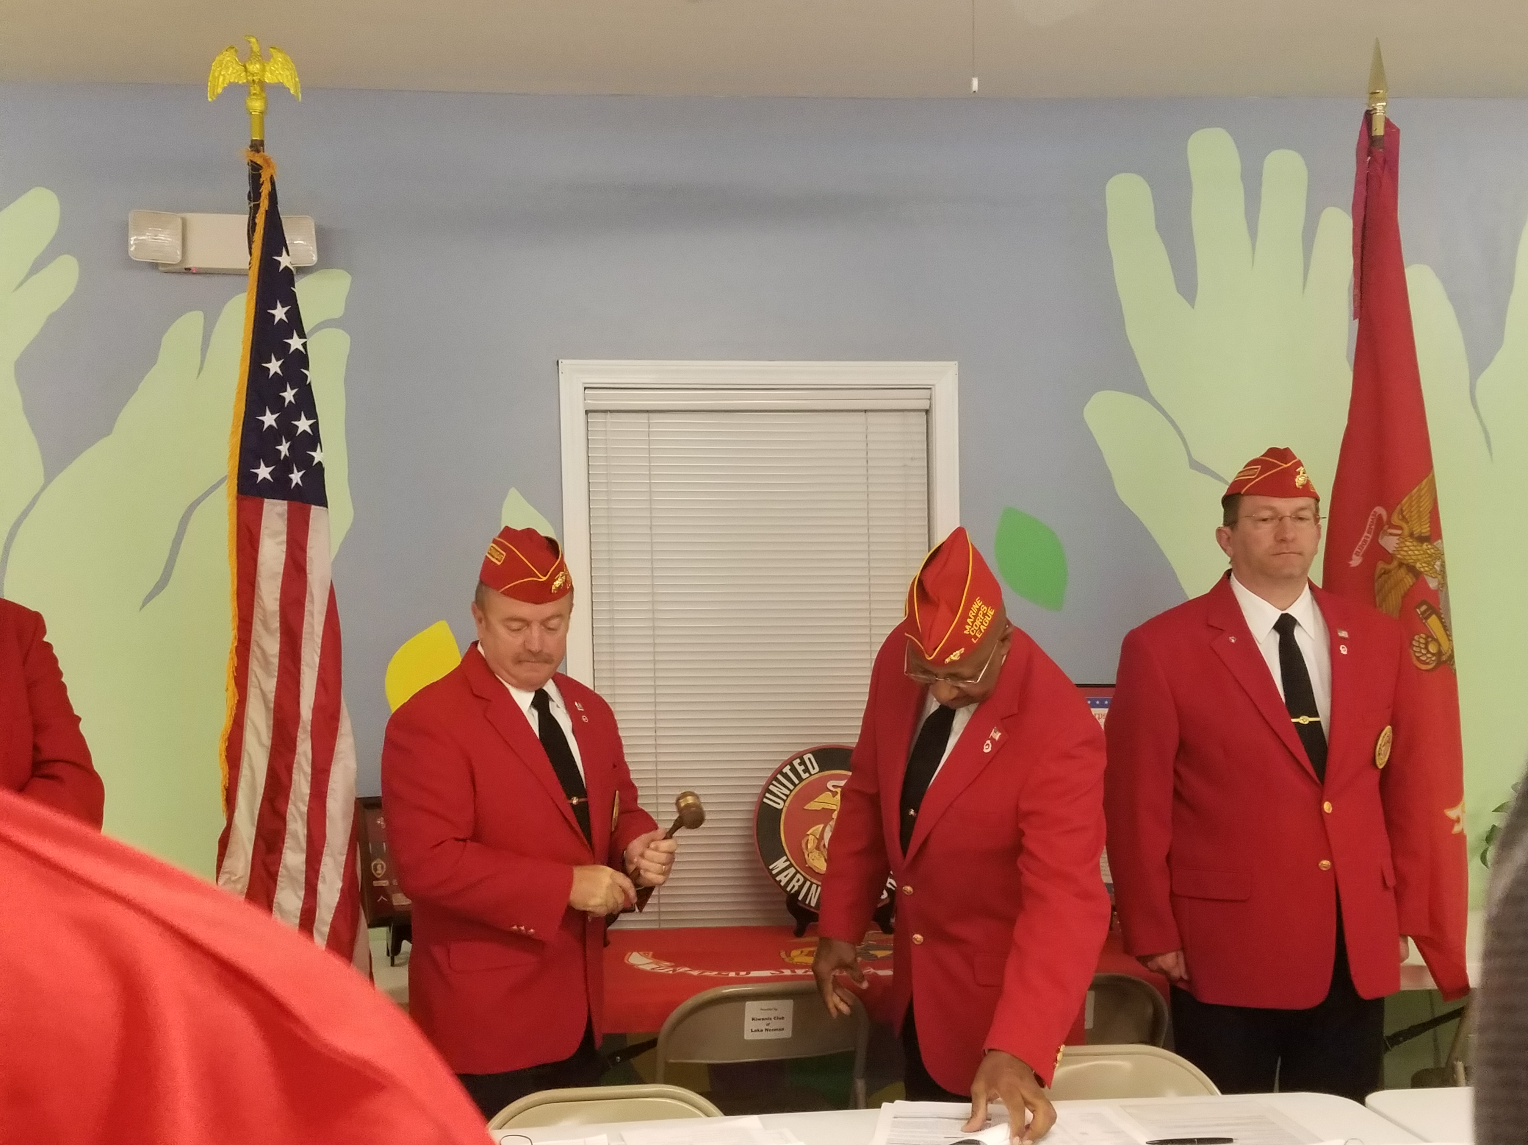

Mission Statement

Members of the Marine Corps League join in camaraderie and fellowship for the purpose of preserving traditions. Promoting the interests of the United States Marine Corps, banding together those who are now serving in the United States Marine Corps and those who have been honorably discharged from that service. Effectively promote the ideals of American freedom and democracy. Voluntarily aiding and rendering assistance to all Marines, FMF Corpsmen and former Marines and FMF Corpsmen and their widows and orphans; and to perpetuate the history of the United States Marine Corps and by fitting acts to observe the anniversaries of historical occasions of particular interest to Marines.​

